Spring 2023

**Monthly Meetings**

Rice City Council - Meets the 1st and 3rd Mondays of the month 6pm

Park Board – Meets the first Tuesday of the month 6 pm.

Planning Commission - Meets the last Monday of the month 7pm

Economic Development Committee—meets the 2nd Tuesday of month 5:15 PM (As needed)

205 Main St E PO Box 179 Rice MN 56367 Phone (320)393-2280

**Mayor:**

Brian Skroch 393-2191

**Council Members:**

Paula Kampa 393-4223 Chris Scheel 393-7847

Michelle Keller 293-6196 Ken Nodo 393-2096



City Hall Office Hours

Monday: 7:00 am – 6:00 pm

Tues-Thurs: 8:00 am – 4:00 pm

Friday: Closed

Please DO NOT flush disposable wipes, cloth towels, or sanitary napkins, etc. in the sewer system. This causes an increase in back-ups in the system. Back-ups result in increased costs and maintenance, and ultimately higher sewer rates. Thank you for your cooperation!

# City Offices Will Be Closed

*Monday, May 29, 2023, Memorial Day &* Tuesday, July 4, 2023, Independence Day

The Board of Appeal and Equalization: April 10th

Mark your calendars for April 10th, 2023, at 6 PM

This may affect your 2023 property taxes.

The purpose of this meeting is to determine whether property in the jurisdiction has been properly valued and classified by the assessor. If you believe the value or classification of your property is incorrect, please contact your assessor’s office to discuss your concerns. If you disagree with the valuation or classification after discussing it with your assessor, you may appear before the local board of appeal and equalization. The board will review your assessments and may make corrections as needed. Generally, you must appeal to the local board before appealing to the county board of appeal and equalization.

Please Call: Benton County Assessor, for an appointment 320-968-5019

**COMPOST 2023**

The compost is set to open Saturday, April 25, 2023 (Weather permitting)

2023 Season April 25th through November 2nd

Hours: 4pm – 7pm Tuesdays and Thursdays 8am – 12pm Saturdays

Permits will be available April 10th at City Hall. Once the compost opens you can purchase/receive a permit on site.

If you are a resident in the city limits of Rice, there is no cost to use the compost however you will still need a sticker.

Non-Residents = $40 for the season or $10 per day

Items accepted: grass clippings, small tree branches and vegetation. Items prohibited: treated wood, concrete, and landscape materials.

No Commercial Dumping and No Bobcat will be available.

**Safe Exchange Zone**

We have now designated an area in front of the police department as a Safe Exchange Zone. To carry out an online style transaction with a stranger or if you need a place to conduct a property or child custody exchange. This area is under 24/7 surveillance and is available to all residents and visitors. The circled spots are the ideal locations to do these exchanges.

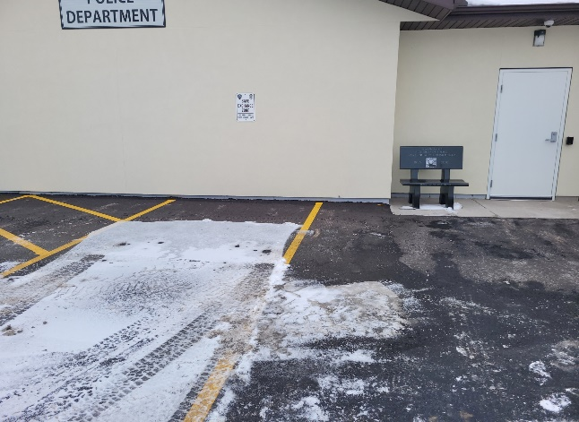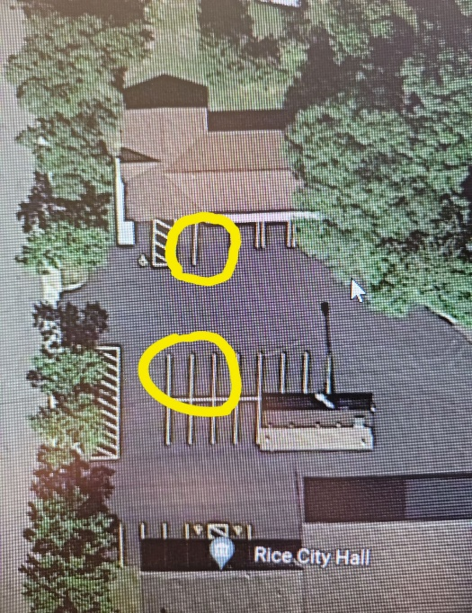

**City of Rice Water Restrictions**

The City has an ODD/EVEN system for watering. Residents with an ODD house number are permitted to water on ODD days and those with an EVEN house number are permitted to water on EVEN days. Ordinance 30 Section 10. WATER CONSERVATION PLANS

If you do not follow the above restrictions, you will be fined $50.00 per offense on you next water bill. No other notice will be given.

**City of Rice Annual Clean-up Day 2023 Saturday, April 8th, 2023**

**8 AM TO 12 PM**

Benton County residents of the City of Rice and the townships of Graham, Langola, and Watab may deposit unwanted articles behind the Rice City Hall. A small fee will be charged for appliances, electronics, and tires. Donation for the food shelf would be appreciated.

ITEM PER UNIT CHARGE

Air Conditioner $5.00

Batteries Free

Couch Free

Chair Free

De-Humidifier/Humidifier $5.00

Dishwasher $5.00

Dryer $5.00

Electronics $5.00

TV’s $30.00

Mattress Free

Box Spring Free

Microwave $5.00

Range/Stove $10.00

Refrigerator/Freezer $10.00

Tires Passenger Vehicle - $4.00

Larger Truck/Tractor - $8.00

Washer $10.00

Water Heater/Furnace $10.00

*NO RV refrigerators, chemicals, paints/stains, pesticides/poisons, hazardous waste, or florescent bulbs. NO Broken or Exposed TV Picture Tubes.

NO CONSTRUCTION DEBRIS.

** Site Personnel have final say on pricing and what items are accepted for drop-off. 

Stay safe by following these rules:

SAVE THE DATE

May 17th, 2023, at 6PM

Bike Rodeo

Sponsored by the Rice Women of Today

To be held in the parking lot at the Westside Park in front of the Lions Building.

More information to come. Please check our website in the future for more details. www.ricemn.us

* Get acquainted with traffic laws; bicyclists must follow the same rules as motorists.
* Ride single file in the direction of traffic.
* Remain alert, keep your head up and look around; watch for opening car doors and other hazards.
* Use hand signals when turning and use extra care at intersections
* Never hitch onto cars
* Before entering traffic, stop and look left, right, left again and over your shoulder

**Rice Recreation**

Rice Rec will be adding Pickle Ball for adults starting February 28th, 2023, at the Rice Elementary Building. Open gym will be from 6:15 - 7:15 pm, pickle ball 7:30 -9:30 pm. Pickle ball will be $5.00, open gym is $2.00. Please check Rice Rec Facebook page or contact Gene @ 320-493-5367 for more information. Summer Ball will start on June 12th, 2023, Soccer TBD, check ricemn.us. or Rice Rec Facebook page.